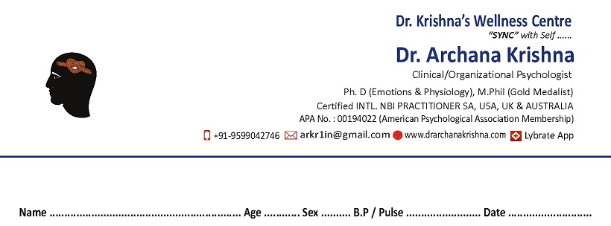

**Name : Age: Gender : Marital Status :**

**Contact no.:**

**Recognizing Your Symptoms of Stress**

**Instructions**—

Use this check sheet to self-assess your stress symptoms.

1.There are four categories given below- Physical, Mental, Behavioral and Emotional.

There are symptoms mentioned, in each category. Kindly Mark the symptoms within yourself, in all the four categories.

2. Next, Mark on the STRESS LOG (Intensity of Stress )-Self Assessment.

**A. Physical**

□ Headaches □ Tension □ Fatigue □ Insomnia □ Weight change □ Colds, respiratory infections □ Appetite change □ Muscle aches (back, neck, etc.) □ Pounding heart □ Dry mouth, throat □ Sweaty hands, feet □ Rashes □ Upset stomach □ Heartburn □ Vomiting □ Diarrhea

**B. Mental**

□ Forgetfulness □ Poor concentration □ Negative attitude □ Lethargy □ No new ideas □ Distrust of others □ Feeling of emptiness □ Loss of direction □ Hopelessness □ Unforgiving □ Cynical □ Continuous need to “prove” self

**C. Behavioral**

□ Poor eating habits □ Foot tapping, finger drumming □ Nail biting □ Grinding teeth□ Restlessness □ Accident prone □ Clenched hands □ Nervous laughing □ Lashing-out at others □ Lowered sex drive □ Nagging□ Fewer contacts with friends □ Increased drug, alcohol, tobacco use

**D. Emotional**

□ Anxious □ Frustrated □ Feel “down” frequently □ Mood swings □ Bad temper □ Nightmares □ Tearful □ Irritable □ Despondent □ Depressed □ Discouraged easily □ Worries □ Seldom joyful □ Constantly resentful □ Lonely

**MY Stress Log**

What was your**average level of stress** in the last four weeks’duration. Put a mark on the scale given below---

1 2 3 4 5 6 7 8 9 10

__________________________________________________________________________________________

No stress Just a little Some A lot of Very

at all stress stress stress stressed

**NOTE-**

In case your marking for **My STRESS LOG** is on **6 or > 6**, then the support of a Psychological Counsellor is recommended.

*Anxiety is a common condition and Professional Counselling / Psycho therapeutic treatments areavailable.*

***You may request ( WHATSAPP ) for a face-to-face appointment on - +91 9599042746***

(Some of the symptoms may be the result of health conditions, so please seek medical care from your doctor).

***NOTE – Professional ethics of your Privacy/ Confidentiality are strictly adhered.s***